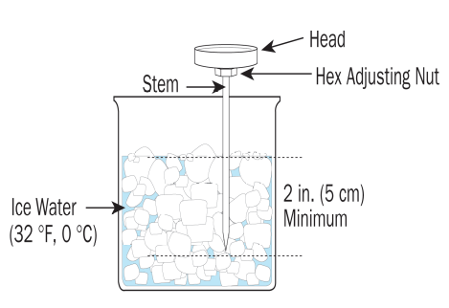

Thermometer Calibration Log (Calibration is the process of resetting a thermometer to read accurately at a known temperature)
Calibration Instructions:
- Fill a large glass with ice and water then stir.
- Immerse thermometer stem 2 inches in water until needle stops moving. Hold the stem away from the bottom and sides to avoid error.
- Rotate the nut (under head) until the pointer reads 32°F while in ice water by using a mini wrench or thermometer cover adjusting hole.
- Calibrate weekly, when thermometer is dropped or when changing from one extreme temperature to another.
- Sanitize thermometers before using by wiping with an alcohol swab or by washing in soap, rinsing and sanitizing.
Date | Temp. Before Calibration | Temp. After Calibration | Calibrated by | Comments | Verified By


