No Bare Hand Contact with Ready to Eat Foods
Frequently Asked Questions

What foods are considered Ready to Eat (RTE)?
- Any food item that will not be cooked prior to service (e.g. sandwich toppings, garnishes)
- Any food item that has already been cooked and is ready for service (e.g. toast, hamburger patty)
- Prepared fruits and vegetables, whether raw or cooked
- Plant food that does not require further washing and processing (i.e. salads & salad ingredients)
- Plant food from which rinds, husks, or peels have been removed
- Bakery items (breads, rolls, pastries) where further cooking is not required
- Ice and garnishes for mixed drinks
- Raw sushi fish and cooked sushi rice
- Garnishes such as lettuce, parsley, lemon wedges, potato chips or pickles
- Any food that will not be thoroughly cooked or reheated after it is prepared
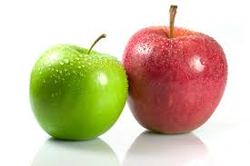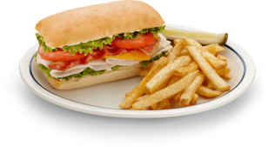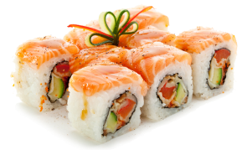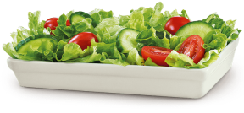
I’ve heard you can actually cross contaminate more with gloves than without. How do I best implement a program?
- Glove use must be tailored to each facility. Cross contamination controls should already be part of every restaurants regular procedure. Gloves must be seen as an additional barrier and should be changed as necessary.
Do we still have to wash our hands in addition to using gloves?
- Yes!! Hands must be washed in addition to wearing gloves and at each time gloves are changed.
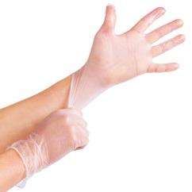
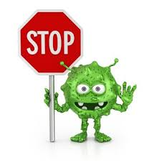
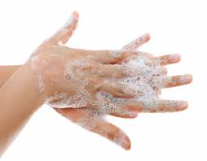
Washing hands and using clean gloves will help prevent the spread of germs.
+ =

Does this mean gloves are required at all times?
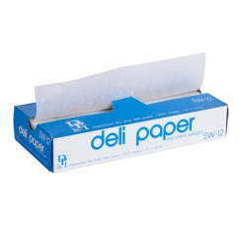
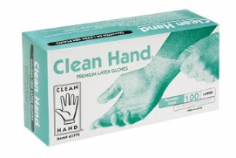
- No. Single-use gloves are one of several acceptable ways to comply with the requirements. Additional tools include tongs, serving spoons, spatulas, deli paper, toothpicks, etc. Gloves are only required when you have cuts, scrapes, burns or other open wounds on your hands.
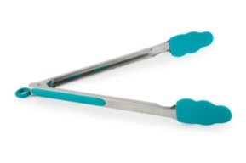
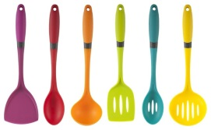

Why the new requirement?
- The primary reason for not touching ready-to-eat foods with bare hands is to prevent viruses and bacteria which are present on your hands from contaminating the food. Improper food handling is one of the most common causes of foodborne illnesses. With proper knowledge, food employees can prevent the transfer of viruses and bacteria from hands to the customer’s food.
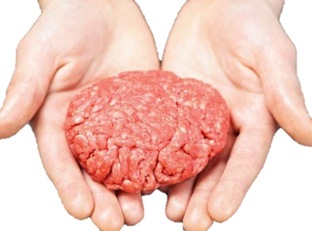
Can bare hands be used to prepare a food that will be used as an ingredient in a food product that will be heat treated prior to service?

- Yes. Since the ingredients are not yet ready-to-eat, bare hands may be used provided that the final food product is heated in accordance with Washoe County Health District Food regulations.

This requirement could be very difficult to implement. Is there an application for approval of Bare Hand Contact in certain instances?
- An application for approval of bare hand contact with RTE Foods can be obtained here: www.washoecounty.us/health/forms-applications.php#fpp
- This application must be submitted AND approved by WCHD prior to commencement of Bare Hand Contact.
How can I get help in implementing my No Bare Hand Contact procedures?
- Food establishments are encouraged to work with their regular inspectors to develop procedures that will comply with the requirements. Contact your inspector regarding procedures, tools, and resources.

Follow us on Facebook to get the latest updates on food safety!
https://www.facebook.com/wchdehs

