Child Care Inspection
Field Guide

Introduction to Child Care Inspections
Washoe County Social Services (WCSS) is the licensing agency for child cares. They issue licenses and inspect all child cares. The Washoe County Health District (WCHD) is responsible for the health and safety inspections under the Regulations for Child Care Facilities, but we do not directly permit the child cares. Most child cares are required to have a food permit, which is issued by the WCHD.
Child cares are inspected in the month that they renew. A health and safety inspection may not be conducted until they pay their inspection fee to WCHD and must be conducted before the license expiration date.
Quality Rating Improvement System (QRIS) is an independent 3rd party audit system that issues a star rating for participating child cares. This is a voluntary program for child cares.
The child care inspection form has three parts: facility information, communicable disease knowledge and reporting, and the physical inspection documentation. It is essential to interview the director and teachers of the child care to determine their knowledge of communicable disease prevention. WCHD provides a communicable disease reporting chart to all child care providers.

Inspection Form Marking Instructions
Part One
Fill out all information on the top of the form, including name, address, email (if available), director, phone number, contact name, number of children licensed for, current enrollment number, age range, hours of operation, permit number, date and time of inspection.
Part Two
You must ask the director or person in charge the 5 questions regarding communicable disease knowledge and reporting. Make sure to ask open ended questions.
Question 1: What are the grounds of exclusion and re-admittance of ill individuals? They may answer directly or state that they look it up on the chart. Acceptable answers include a fever, vomiting, diarrhea with re-admittance 24 hours after symptoms stop without the use of fever reducing medication. See the Communicable Disease Chart for further information.
Question 2: What are the precautions you can take to prevent an outbreak? Answers include: to isolate and exclude ill individuals (children and caregivers), wash hands, clean and sanitize. In a non-outbreak situation children may return 24 hours after symptoms have stopped, however caregivers must be excluded 48 hours after symptoms stop as they handle children’s food and fall under our food regulations as a food handler.
Question 3: When would you expect that you have an outbreak occurring? Answer: When there is an unusual increase in illness. They may provide a number, such as 2-3 if it’s a small center. Ten percent is not an acceptable answer.
Question 4: How do you track your ill individuals in order to determine if there is an increase in illness? They may have formal or informal ways of doing this including a computer program, a log sheet or a notebook. So long as they are tracking people they send home and call ins. Be sure to remind them that when someone calls in sick, they must ask what symptoms they have to appropriately apply their exclusion guidelines.
Question 5: What do you do if you suspect you have an outbreak occurring? They must call WCSS at 337-4470 and the WCHD at 328-2447.

Part Three
These items are determined to be in compliance or not based on interviews of the director, caregivers, and a physical inspection of the childcare. Each section listed below includes the potential violations that are marked under that section. If ‘Non applicable’ is available, it will be noted under that section. Section numbers refer to chapters/sections in the Regulations for Child Care Facilities.
19.3.A: Hand washing training program for children/staff.
Director should be interviewed regarding how they teach hand washing and what constitutes a good hand wash. Hands must be washed with the following procedure: wet hands with warm running water and apply soap, rub hands together with soap vigorously for 20 seconds, rinse hands well under warm running water, dry hands with paper towel or air dryer. Item should be marked ‘in’ based on overall assessment of interviews.
19.3.B&C: Children and infant’s hands are washed as needed.
Caregivers must monitor and assist as needed children who are developmentally able to wash their hands to ensure the proper procedure is followed.
Infants who are unable to wash their own hands and are too heavy to hold safely at the hand sink may have their hands washed with a disposable wipe. Once children are able to crawl, their hands should be washed at the handsink. Any violations must be corrected on site by having the caregiver wash the children’s hands.
19.3.B: Each child’s hand washing practice is monitored.
Caregivers must monitor and assist as needed children who are developmentally able to wash their hands to ensure the proper procedure is followed. This includes monitoring a single child sent in from the playground to use the bathroom. Any violations can be corrected on site by having the caregiver monitor the children.
19.3.D: Child care facility monitors staff’s hand washing.
Interview director regarding how they monitor staff’s hand washing, and interview staff on when and how to properly wash hands. Make sure to ask open ended questions.
19.3.E&F: Hands washed when required.
Observe class rooms and interview caregivers to ensure hands are washed under the following circumstances: any time there is contact with bodily fluids, before preparing food, before and after eating, after toileting/diapering, after taking care of an ill individual, after handling an animal, after taking out the garbage, after cleaning contaminated surfaces, before and after giving medication, after playing in water or sand, or any other time hands become visibly soiled. As hand washing is the number one way to prevent communicable disease transmission, diligent observation in each class room must take place. A single observation of a missed hand wash should be marked out and corrected on site by having the caregiver/child wash hands.
19.4: Outdoor playground safe, fenced, shaded area.
Outdoor play areas shall be inspected for the following items:
- Fenced area no less than 48 inches in height and no vertical gaps more than 4 inches, with self-closing and latching gates.
- Have an adequate drainage system.
- Be free of hazards, debris and trash. Be sure to ask if they have issues with feral cats or other animals and how those issues are handled, i.e. covering sand boxes at night.
- Provide a shaded area.
- Have sufficient resilient surface (bark, tire chips, sand, etc.) under play equipment.
- Safety barriers around all elevated surfaces.
- No dangerous/poisonous plants.
- No accessible bodies of water.
- All equipment in good repair, no protruding screws, no broken plastic, securely anchored.
27.6: Menus conspicuously posted & on file for 90 days.
Child cares must plan one week in advance and keep for 90 days menus for all food served, including breakfast, lunch, dinner and snacks. Menus must be kept for trace back purposes.
N/A may be marked if the facility does not serve any food to children, i.e. parents provide all snacks and lunches.
27.7: Child’s name on bag lunch / temperature maintained.
When parents provide lunches for their children, they must be labeled to ensure they are given only to that child. This also applies to water bottles and breast milk for infants. IT IS CRITICAL THAT BREAST MILK BE LABELED SO THAT IT IS NOT SHARED – IT HAS SERIOUS HEALTH RAMIFICATIONS.
Temperature violations, i.e. food over 41F, must be corrected on site. If it’s a refrigerator with TCS foods, TCS foods must be discarded. It is not required, but you can provide refrigerator temperature logs for the center. Centers are allowed to have home style refrigerators.
27.10: Drinking water supply safe/readily available.
Child cares can provide a water fountain connected to a potable water supply. Child cares may also choose to provide bottled water. Drinking water may not be obtained from a handsink. Water used to prepare infant formula must be obtained from a prep sink, and may never be taken from a hand sink. A drinking fountain may share the same basin as a hand sink, but may not be connected to the hand washing faucet. Inspector shall discuss cleaning and sanitizing of drinking fountain.
27.12: Children not allowed in kitchen except for training.
Children are not allowed in the kitchen, except for during supervised learning projects. Kitchen should be locked or otherwise secured. See Appendix A on requirements for cooking activities.
28.2: Kitchen permit present if required.
See Appendix B on what foods are allowed with and without a permit. Child cares are exempt from many of the food permit construction requirements. Child care kitchens must have a minimum 2 compartment sink (one labeled and used for hand washing only, the other for dumping and filling the 3 tub system). They may use home style refrigerators and a 3 tub system instead of a 3 compartment sink.
29.2: Child care inspection reports on file – minimum 2 years.
Child cares must have past inspection reports on file.
29.3.A&P: Premises and equipment are safe and clean.
The grounds of the child care must be free of trash, vermin, tripping hazards, broken play structures, and all equipment must be smooth and easily cleanable. Common violations may include: remove broken toys or plastic play structures, remove protruding screws, repaint wood tables, replace torn furniture/toys, dirt/debris accumulation. All outlets must have covers or have something plugged into them.
29.3. B: Chemicals are labeled, inaccessible to children.
All cleaning chemicals must be labeled, properly stored away from food and locked to prevent access by children.
Any items stored within reach must be immediately moved or locked up.
29.3.C: Procedure for cleaning floors followed.
All carpets or rugs too large to be placed in a washing machine must be vacuumed at least once per day and professionally cleaned at least once every 3 months. Other flooring must be swept and mopped at least once per day. Public Vomiting Incidents (PVI’s) must be cleaned immediately with 1000ppm bleach on hard surfaces or with a steam cleaner that reaches 170°F. Facilities may clean floors with professional grade equipment to meet this regulation. A home style carpet cleaner does not meet this requirement.

29.3.D: Cleaning and sanitizing done when needed.
All toys for non-diapered children must be washed, rinsed, sanitized and allowed to air dry at least weekly. All toys for diapered children must be washed, rinsed, sanitized and allowed to air dry daily. Any toys that a child puts in their mouths must be washed, rinsed, sanitized and allowed to air dry after each use by a child. Centers may remove mouthed toys to a dirty bucket to be washed at the end of the day, so long as another child is not allowed to play with the toy. Dramatic play clothing must be laundered weekly. Hats must be laundered or cleaned if they are plastic after each use to prevent the spread of lice.
Facility should have a cleaning schedule for each classroom to keep track of cleaning items. This may be formal or informal.
Sensory bins should be changed out and sanitized weekly. Their use should be discontinued during an outbreak.
Water play tables should be changed out and sanitized daily.
If they are labeled for an individual child, nap linens and mats/cots must be washed weekly. If they are not labeled, they must be washed, rinsed and sanitized (or laundered) after each use. Plastic or vinyl cots or mats must go through the 3 step process. This may be accomplished with spray bottles. Lysol/Clorox spray or wipes are not approved for use in sanitizing.
If a child soils their clothing, it must be bagged and sent home to be cleaned. It should not be washed at the center.
If a center does not have laundry machines, it may be taken home by the director or staff to be done.
Infant bottles may be washed and sanitized in the center if the center has a separate area to wash them. The sink may not be a hand sink. Sanitizing bottles must be done according to the food regulations, 50-100ppm chlorine, not child care concentrations. If the facility does not have a kitchen permit or any other sink not used for hand washing, parents must provide a sufficient supply of bottles for their child for the day. They must be sent home with the parents for cleaning. If the center does wash bottles, a separate labeled bottle brush must be used for each child’s bottles.
See Appendix E for Addendum 11 Cleaning Chart.
29.3.E&F: Sanitizer prepared and used correctly.
Bleach solutions must be made fresh daily, according to the mixing chart in Appendix C. This concentration is much higher than in the food facilities. Child cares with kitchens must use the 50-100ppm chlorine concentration for food items.
Sanitizer may only be used after items are washed and rinsed. Contact time for bleach is 30 seconds. Dishwashers may be used in child cares, however they must dispense the child care concentration for bleach or the center may use a 3rd compartment for sanitizing. You will occasionally see high temperature sanitizers in some centers; they should have a way to verify the final rinse. Many of these are a high temperature rinse only and the items must first be washed and rinsed before placing in the sanitizer. All items must be fully air dried before placed back into play.
Some child cares do not wish to use bleach. They may use other alternate sanitizers so long as it is an EPA registered sanitizer approved for use in child cares or schools. They must follow the 3 step process (wash, rinse, sanitize) and allow for proper contact time for the alternate sanitizer. Most alternate sanitizers have a contact time of 2-10 minutes. Centers will be required to use bleach in an outbreak.
Any sanitizer not prepared or used in accordance with the regulations or manufacturer’s instructions shall be immediately discarded.
29.3.G: Dirty linen stored separately.
Dirty linens shall be stored separately from all clean linens, food, personal items, etc.
Dirty linens stored on top of clean linens shall be immediately removed and all linens re-laundered.
29.3.H: Personal items separately stored and labeled.
Personal items include hairbrushes, toothbrushes, towels, blankets, pacifiers, teething toys, personal clothing. These items must be labeled, stored separately and not shared between children. Each child should have their own labeled storage hook or cubby for their items.
Some centers teach tooth brushing. Tooth brushes must be labeled and stored to prevent contamination, i.e. they may not share a common cup. When dispensing tooth paste, the bulk tube must not touch each brush, instead tooth paste may be placed on a cup or paper towel for each child to scoop up. Brushing is often conducted at a hand sink, but should be from a separate water fountain spigot.
29.3.I: Sleeping accommodations are appropriate.
If a center has nap or rest period, the center must provide cots or mats with cleanable covers. Each cot must be at least 2 feet apart. Lights may be dimmed for nap time, but there should be sufficient lighting for supervision. Cribs may be placed end to end if the ends are shielded and not slatted. Slats on cribs may not be more than 2 and 3/8 inches apart. Nap cots/mats may be cleaned weekly if they are labeled for use by one child. This may be marked N/A if the facility is a drop in center in which the children are there for a limited time and do not take naps.
29.3.J: Bathrooms are properly stocked and clean.
Bathrooms are stocked with toilet paper, soap and paper towels. Bathrooms are clean. One hand wash sink is needed for every 15 children.
Any bathrooms not stocked must be immediately stocked by staff.
29.3.K: Diaper changing areas fully equipped.
Diaper changing areas need a smooth surface, not be located in a kitchen or area where food is prepared, have a trash can with a lid, and generally in good repair. This may be marked N/A if the facility is licensed for children 3 and over and does not conduct regular diaper changes.
29.3.K: Hand sink within 5 feet of diaper changing area.
Hand sinks must be located within 5 feet of a diaper changing area. Some centers have been approved to use a portable hand sink, however this sink must be stocked and turned on at all times. If a facility fails to stock and use the portable hand sink, they may be required to install a regular plumbed hand sink. This may be marked N/A if the facility is licensed for children 3 and over and does not conduct regular diaper changes.
29.3.L: Diaper changing procedure posted & followed.
See Appendix D for diaper changing procedure. If possible, at least 1 diaper change should be observed. At a minimum, a staff member should be asked to describe the procedure. A procedure must be posted at each diaper changing area. This may be marked N/A if the facility is licensed for children 3 and over, and does not conduct regular diaper changes. Facility must have a procedure to address when a child has an accident.
29.3.M: Diaper area secured, children supervised.
Children should not be allowed to play in the diaper changing area, should not be left unattended while changing diapers, and prevented from getting into the trash can with dirty diapers. This may be marked N/A if the facility is licensed for children 3 and over, and does not conduct regular diaper changes.
29.3.N: Approved solid waste storage and disposal.
Centers must have approved trash bins that are picked up at least weekly. Directors may not take trash home for disposal. Trash collections areas must be kept clean and free from vermin.
29.3.O: Unused refrigerator/freezer secured.
If a center has an unused refrigerator it must be secured from access by the children. This may be marked N/A if the center does not have any unused refrigerators.
29.3.Q: Pet guidelines followed.
Facilities may have animals, which may include dogs, cats, fish, guinea pigs, rabbits. No dangerous or aggressive animals are allowed. Facilities having pets must:
- Keep the cages clean and sanitary,
- Litter boxes must be kept out of reach of the children and out of kitchen area,
- Pets are not allowed in kitchen area,
- Pets must be kept up to date on all vaccines/shots and records must be available at time of inspection,
- Reptiles are allowed, but may not be handled by the children.
This section may be marked N/A if the facility does not have any pets.
29.3.R: Hand sinks are properly stocked and clean.
All hand sinks are stocked with liquid pump soap and paper towels or air dryer within 4 feet of the hand sink. Hand sinks are for hand washing only and may not be used for any other task. If the faucet has a metered faucet, it must be adjusted to have at least 15 seconds of flow before reactivation is needed.
Any hand not having soap and paper towels must be immediately stocked by staff.
29.3.R: Hand sinks have warm water, max of 100°F.
Water in the child care center may not exceed 100°F. Use a thermocouple to measure temperature. Child cares that have a kitchen permit are required to maintain 110°F for manual warewashing. This may require a booster pump in the kitchen area if it is connected to the same water heater.
29.3.R: Hand washing sign posted in each restroom.
Each restroom is required to have a hand washing sign. The sign should be age appropriate for the children.
29.3.S: Proper cleaning clothes/materials used.
Single-use disposable towels, single-use disposable sponges or reusable cloth rags may be used for cleaning. Rags must be laundered separately and placed in a hot dryer after each use.
29.4: Pools/bodies of water are safe/secured/sanitized.
If a swimming pool or hot tub is on the property, it must be secured by a fence at least 4 feet high, with no vertical opening larger than 4 inches, no bottom opening more than 4 inches, have a self-closing and self-latching gate. Pools must be operated in accordance with WCHD pool regulations.
Wading pools may be used so long as the water does not exceed 6 inches, emptied when not in use, cleaned and sanitized after each use, children are always supervised.
This item may be marked N/A if the center does not have any pools.
29.5: Sufficient monitors for water activities.
If a facility provides water activities in a depth greater than 6 inches: no child may be in water higher than their chest while standing, at least 1 caregiver is within arm’s reach for any child less than 3, children may not enter a moving body of water (river, creek, ditch), at least 1 person is a certified life guard. Facilities must offer another activity in addition to the optional water activity.
This section may be marked N/A if the center does not offer activities in water more than 6 inches.
29.6: Smoking prohibited.
Smoking is prohibited in child care facilities, on play grounds, within 20 feet of entrances, and in vehicles used to transport children. No smoking signs must be posted at all entrances.
Any employees observed smoking must immediately quit or move to an appropriate location.
29.7: Facility and grounds free of vermin.
Child cares must ensure play grounds and buildings are free from vermin. If needed, pest control may be required.
29.8: Heating and cooling sufficient.
Child care centers shall be maintained between 68 – 82°F April through September and between 65 – 82°F October through March.
29.9: Lighting is adequate in child care facility.
Adequate lighting is required in all areas of the child care. Lighting requirements specified in the WCHD Regulations Governing Food Establishments for cleaning and general sanitization may be used as guidance.

Appendix A
Classroom Cooking Guidelines
***Plans must be site specific. This document must be modified to accommodate each facilities’ equipment. IE: If a facility does not have an oven, they may not cook any muffins.***
**A copy of each site specific plan must be available on site during inspection**
Site Name
An approved and current Washoe County kitchen permit must be available for each facility conducting food activities. All activities will be conducted under the supervision of a certified food protection manager.
Read recipe to ensure you have all ingredients and cooking tools readily available. Follow steps in recipes. A copy of all recipes used will be attached to this plan.
Handwashing
Wash hands thoroughly with warm soapy water for at least 20 seconds, washing fronts and backs, in between fingers and thumbs, rinse with water, dry with paper towels and turn off faucet with paper towel. Teachers must wear gloves or use utensils any time they are contacting ready to eat food.
- Wash hands after the cooking activity or as needed throughout, any time cross contamination may have occurred (touching face or hair, hands in mouths, going to bathroom).
- Gloves or utensils must be used at all times when handling ready to eat foods (food that will not be cooked).
Employee Exclusion
Any employees or students that are ill with vomiting, diarrhea, cough or sore throat and fever are excluded from the activity and will be appropriately excluded from the facility according to the child care exclusion policy. All teachers must be symptom free for 48 hours before handling any food.
Food
All recipes must conform to Washoe County Food Regulations regarding child care kitchens, including no raw meat, no cutting melons, leafy greens or tomatoes. The only exception is that raw shell eggs may be used in a product that will be baked.
All food is purchased from an approved source, no ingredients are allowed from home. All food will be purchased and taken immediately to the center.
All ingredients will be stored as needed in a refrigerator holding food at 41ᵒF or below.
Any commercially packaged items (yogurt, butter) opened for the activity will be date marked and must be used or discarded within 7 days.
Cooked foods must be checked for internal temperature according to the recipe specifications.
There is to be no cooling of any hot foods. No left overs may be kept.
Preventing Contamination
All food and dishes must be stored to prevent their contamination.
All cleaning chemicals, including bleach, are stored in a locked cabinet inaccessible to children. Chemical storage must be completely separate from all food storage.
Food will be served to students in individual servings. No common bowls are allowed. Students may serve themselves with proper utensils and under supervision of the CFPM. Should any cross contamination occur (such as a student putting a utensil in their mouth and then in the common bowl) the food shall be discarded.
Washing and Sanitizing
Always clean items that were in contact with foods thoroughly. All cooking activity items are taken to the kitchen to be washed, rinsed, sanitized (50-100ppm chlorine or 200-400ppm quaternary ammonia), and allowed to air dry. No dishes may be done in the classroom.
Wash and sanitize cooking area. Cooking area will be cleaned with soapy water, then rinsed with clean water, then sanitized (50-100ppm chlorine or 200-400ppm quaternary ammonia) and allowed to air dry.

Appendix B
Childcare Kitchen Regulation Summary

The following items are PROHIBITED in all childcare kitchens, regardless of permit/CFPM:
- Raw and partially cooked animal foods (fish, shellfish, steak, soft cooked eggs, meringue)
- Raw seed sprouts
- Raw/unpasteurized milk
- Packaged juice that has been labeled “WARNING: This product has not been pasteurized and, therefore, may contain harmful bacteria that can cause serious illness in children, the elderly, and persons with weakened immune systems.” If a childcare wishes to serve fresh squeezed juice, it must be done under a preapproved HACCP plan.
- Raw eggs. Pasteurized eggs must be substituted in the preparation of foods, such as ‘green eggs and ham’. The only time raw shell eggs (unpasteurized) may be used is in a recipe that is immediately cooked to a ready to eat form, such as muffins, cake or cookies.
- Honey to children under 1 year of age
- Cutting melons, leafy greens, or tomatoes. (These items may be purchased already cut.)

The following items are allowed if the center does NOT have a kitchen permit:
- Preparing formula for infants – water may not be obtained from a handwashing sink.
- Any food provided by the CENTER must meet the following criteria:
  - Commercially packaged and non-potentially hazardous (does not require refrigeration)
  - Food is in single service packages (one serving)
  - Package must be opened immediately before serving to child
  - Food is only eaten by 1 child
  - Any left overs are thrown out
  - If utensils are needed: must be single use and thrown out immediately, or a reusable utensil must be provided by that child’s parent and sent home daily.
- Any food provided by the PARENTS must meet the following criteria:
  - Food is for the exclusive use of the child (no sharing)
  - Food must be labeled for the individual child
  - Potentially hazardous foods must be refrigerated
  - All food must be protected from contamination
  - Food items must be ready to serve – no mixing, adding ingredients (except water), preparing, hot holding, thawing, cooking
  - Food may be reheated in a microwave for consumption only, not for safety (may not cook a raw chicken breast, but may reheat leftovers)
  - Any left overs are thrown out
  - If utensils are needed: must be single use and thrown out immediately, or a reusable utensil must be provided by that child’s parent and sent home daily.
- Foods brought for special occasions (birthdays, Christmas party, etc)
  - May be baked at the home of a child enrolled in the center
  - Must be non-potentially hazardous (cannot require refrigeration), ie cookies, brownies, cakes. May not have cream filling, whipped cream, or other frostings that require refrigeration.
  - Parents must be informed that the baked goods were made in a kitchen that is not subject to inspection by the Health Authority.
  - Parents must be given an option to ‘opt out’ of the consumption of these items.

The following items are allowed if the center has a kitchen permit, but not a CFPM (certified food protection manager):
- Cutting fruits and vegetables such as apples, bananas and oranges. A center may NOT cut melons, leafy greens or tomatoes.
- Pouring milk as a beverage or onto cereal.
- Serving non-potentially hazardous snacks from bulk, i.e. placing crackers onto plates for an individual child.
- Warming in the original package of any precooked/pasteurized potentially hazardous food items, such as ‘TV dinner’.

ALL OTHER FOOD ACTIVITES REQUIRE A KITCHEN PERMIT
AND A CERTIFIED FOOD PROTECTION MANAGER.

COOKING ACTIVITES REQUIRE A KITCHEN PERMIT, CERTIFIED FOOD PROTECTION MANAGER
AND A WRITTEN FOOD SAFETY PLAN.

Appendix C
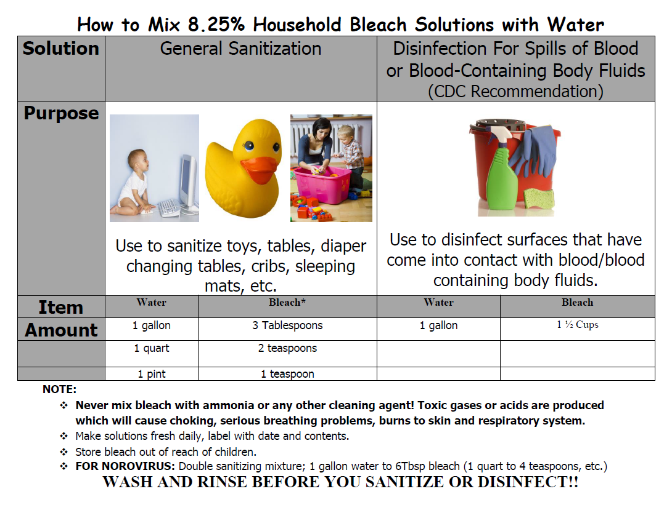

Appendix D
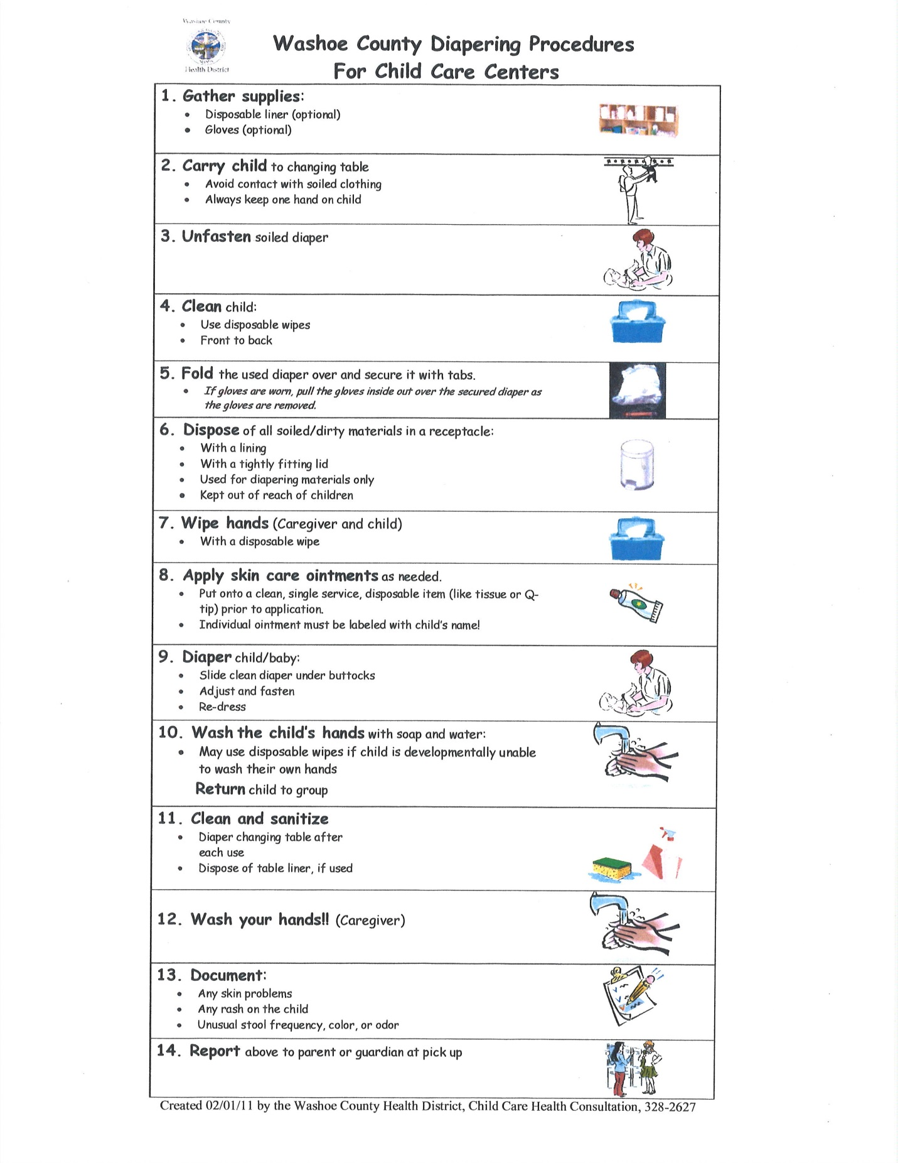
Appendix E
